John Michael Go
Career Entry Level Java Programming
Date: Jan. 17, 2013

DAY 5

Program Name: DateTime

Objective: First Date and Time example

Algorithm:

- Program outputs first date and time format.

Flowchart:

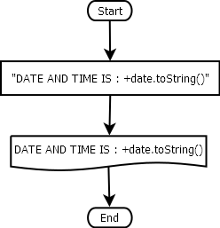

Pseudocode:

/* Program Name: DateTime
Created By: John Michael Go
Creation Date: Jan. 17, 2013 Day 5
Note: First Date and Time example
*/

import java.util.*;
import java.io.*;

public class DateTime{

static Scanner console = new Scanner (System.in);

public static void main(String[]args){

Date date = new Date();
System.out.print("DATE AND TIME IS:");
System.out.println("\n" +date.toString());
System.out.print("");

}

}

Screenshot:

